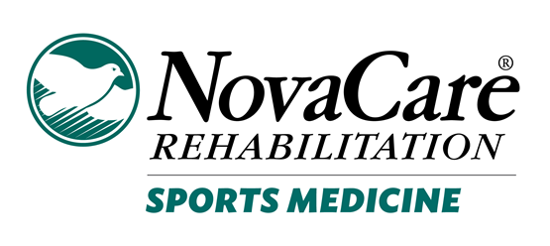

Post-concussion Consent Form
(RTP/RTL)
Date ______________________________

Student’s Name__________________________ Year in School 9 10 11 12

By signing below, I acknowledge the following:

1. I have been informed concerning and consent to my student’s participating in returning to play in accordance with the return-to-play and return-to-learn protocols established by Illinois State law;

2. I understand the risks associated with my student returning to play and returning to learn and will comply with any ongoing requirements in the return-to-play and return-to-learn protocols established by Illinois State law;

3. I consent to the disclosure to appropriate persons, consistent with the federal Health Insurance Portability and Accountability Act of 1996 (Public Law 104-191), of the treating physician’s or athletic trainer’s written statement, and, if any, the return-to-play and return-to-learn recommendations of the treating physician or the athletic trainer, as the case may be.

4. Also I acknowledge that my student athlete will not return to full participation of academics and play until the protocols are completed and released by athletic trainer and/or physician.

Student’s Signature ______________________________________________________

Parent/Guardian’s Name __________________________________________________

Parent/Guardian/s Signature _______________________________________________
For School Use only
Written statement is included with this consent from treating physician or athletic trainer working under the supervision of a physician that indicates, in the individual’s professional judgement, it is safe for the student to return-to-play and return-to-learn.

Cleared for RTL Cleared for RTP
Date :_________________________________ Date:_________________________________

