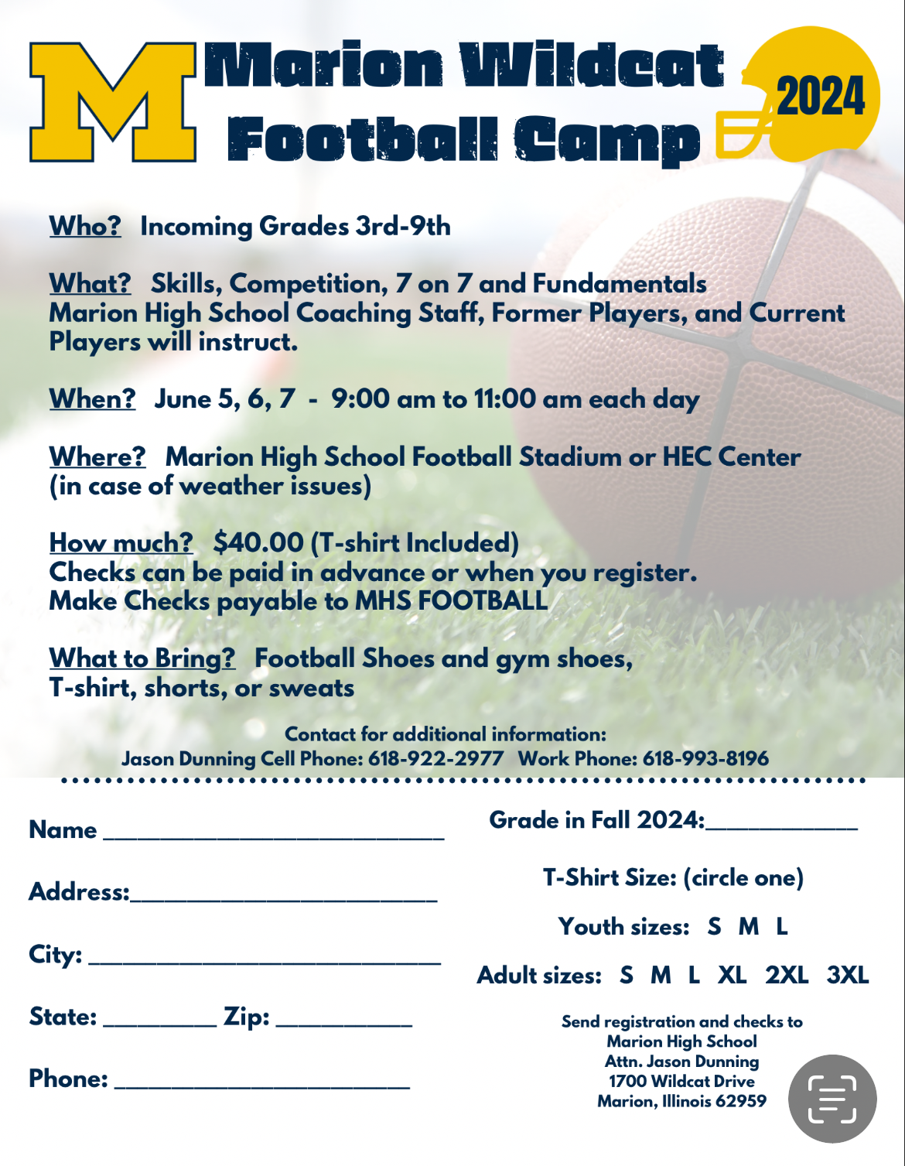

Release and Waiver of Liability and Indemnity Agreement
(Read Carefully Before Signing)

In consideration of being permitted to participate in any way in the Marion Unit #2 Camp program indicated below and/or being permitted to enter for any purpose any restricted area (herein defined as any area where in admittance to the general public is prohibited, the parent(s) and/or legal guardian(s) of the minor participant named below agree:

The parent(s) and/or legal guardian(s) will instruct the minor participant that prior to participating in the below camp activity or event, he or she should inspect the facilities and equipment to be used, and if he or she believes anything is unsafe, the participant should immediately advise the officials of such condition and refuse to participate. I understand and agree that, if at any time, I feel anything to be UNSAFE, I will immediately take all precautions to avoid the unsafe area and REFUSE TO PARTICIPATE further.

I/We fully understand and acknowledge that:
-There are risks and dangers associated with participation in all camp events and activities which could result in bodily injury, and/or total disability, paralysis and death.
-The social and economic losses and/or damages, which could result from these risks and dangers described above, could be severe.
-These risks and dangers may be caused by the action, inaction or negligence of the participant or the action, in action or negligence of others, including, but not limited to, the releases named below.
-There may be other risks not known to us or are not reasonably foreseeable this time.

I/We accept and assume such risks and responsibility for the losses and/or damages following such injury, disability, paralysis or death, however caused and whether caused in whole or in part by the negligence of the releases the nappmed below.

I/WE HEREBY RELEASE, WAIVE, DISCHARGE AND COVENANT NOT TO SUE the Marion Community Unit School Dist. #2 facility used by the participant, including its owners, managers, promoters, lessees of premises used to conduct the camp event or program, premises and event inspectors, underwriters, consultants and others who give recommendations, directions or instructions to engage in the risk evaluation or loss control activities regarding the football facility or events held at such facility and each of them, their directors, officers, agents, employees, all for the purposes herein referred to as “Release”…FROM ALL LIABILITY TO THE UNDERSIGNED, my/our personal representatives, assigns, executors, heirs and next of kin FOR ANY AND ALL CLAIMS, DEMANDS, LOSSES OR DAMAGES AND ANY CLAIMS OR DEMANDS THEREFORE ON ACCOUNT OF ANY INJURY, INCLUDING BUT NOT LMITED TO THE DEATH OF THE PARTICIPANT OR DAMAGE TO PROPERTY, ARISING OUT OF OR RELATING TO THE EVENT(S) CAUSED OR ALLEGED TO BE CAUSED IN WHOLE OR IN PART BY THE NEGLIGENCE OF THE RELEASEE OR OTHERWISE.

I/We HEREBY acknowledge that THE ACTIVITIES OF THE EVENT(S) ARE VERY DANGEROUS and involve the risk of serious injury and/or death and/or property damage. Each of THE UNDERSIGNED also expressly acknowledges that INJURIES RECEIVED MAY BE COMPOUNDED OR INCREASED BY NEGLIGENT RESCUE OPERATIONS OR PROCEDURES OF THE RELEASEES.

EACH OF THE UNDERSIGNED further expressly agrees that the foregoing release, waiver, and indemnity agreement is intended to serve as broad and inclusive as is permitted by the law of the Province or State in which the event is conducted and that if any portion is held invalid, it is agreed that the balance shall, notwithstanding continue in full legal force and effect.

On behalf of the participant and individually, the undersigned parent(s) and/or legal guardian(s) for the minor participant to execute this Waiver and Release. If, despite this release, the participant makes a claim against any of the Releasees, the parent(s), and/or legal guardian(s) will reimburse the Releasee for any money which they have paid to the participant, or on his behalf, and hold them harmless.

I HAVE READ THIS RELEASE AND WAIVER OF LIABILITY, ASSUMPTION OF RISK AND INDEMNITY AGREEMENT, FULLY UNDERSTAND ITS TERMS, UNDERSTAND THAT I HAVE GIVEN UP SUBSTANTIAL RIGHTS BY SIGNING IT, AND HAVE SIGNED IT FREELY AND VOLUNTARILY WITHOUT ANY INDUCEMENT, ASSURANCE, OR GUARANTEE BEING MADE TO ME AND INTEND MY SIGNATURE TO BE COMPLETE AND UNCONDITIONAL RELEASE OF ALL LIABILITY TO THE GREATEST EXTENT ALLOWED BY LAW.

Facility: Marion Community Unit School District #2
Parent or Guardian Signature (if minor)_____________________________________________________
Parent or Guardian Signature (if minor)_____________________________________________________
Printed Name of Participant______________________________________________________________
Address of Participant___________________________________________________________________
Received by:
Registrar Signature Printed Name Member# Region on File Date

