Athletic Registration

We have simplified the registration process, and all waivers are now signed digitally! Please be sure to follow these steps to complete your registration and ensure that your student is registered for athletic participation:

- Create an Arbiter Registration account (you only need one account for your whole family)
- You may create your account by clicking here.

- Activate your Arbiter Registration account from the activation link that will be automatically sent to your email. (Note: this email may go into your junk folder).
  - If you are having trouble creating your account, receiving the activation email, or logging in, you may contact support at registration@arbitersports.com or call us at 800-311-4060.

- Once you have successfully created your account and are logged in, please click or scan the QR below to complete your registration:
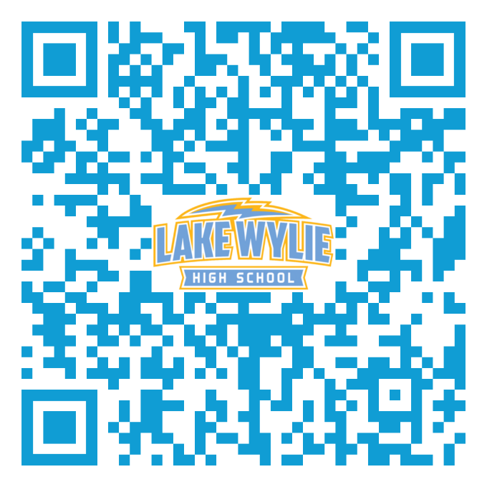

4. Once you have completed your registration, you will receive an email notification to let you know we have received your registration. Students MUST be registered and cleared to be eligible for participation.

