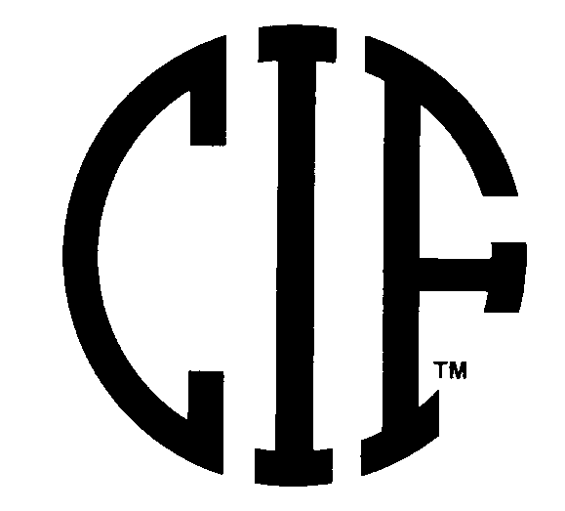 | PARENT PERMISSION FORM  CIF/CCS Weight Certification Program | 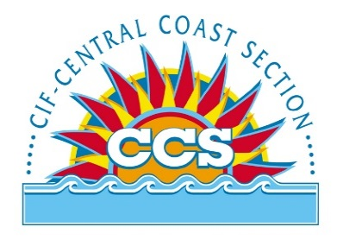

I hereby grant____________________ High School permission to allow a weight assessment to be performed on my son/daughter by a CIF Certified Assessor, for the purpose of determining if the appropriate body fat percentage has been met under the CIF Wrestling Weight Certification Program. I understand that the CIF requires this assessment to be completed in order for my son/daughter to be eligible to compete in wrestling in any CIF Competition.
I hereby agree to release, discharge and forever hold harmless the CIF, CCS, the school, and CIF Certified Assessor from any and all claims, which I might now, or hereby have with respect to the body fat assessor that I am consenting to herein. I am free to deny any consent for my son/daughter both now and at any point during the testing.
I acknowledge that I have read this form in its entirety or it has been read to me, and I understand the weight certification program procedure in which my son/daughter will be engaged. I consent and give permission for my son/daughter to participate in the weight certification testing.

NAME OF STUDENT ATHLETE____________________________________________________

NAME OF PARENT/GUARDIAN____________________________________________________

PARENT/GUARDIANSIGNATURE__________________________________________________

DATE_________________

