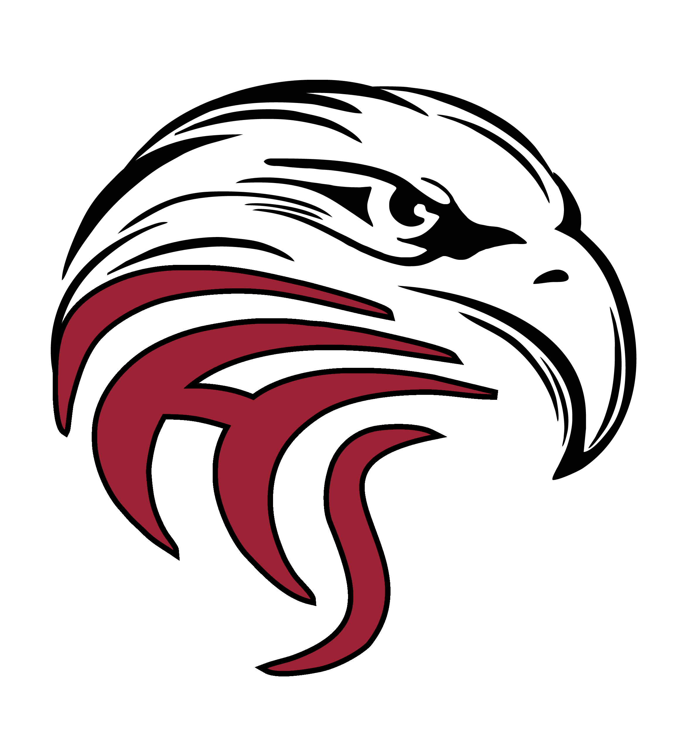
2022-2023
Colville High School

Varsity Wrestling Schedule

Day | Date | Time | Opponents/Title | Site
Wed | 11/30 | 3:00 PM | Lakeside Shoot Out | Lakeside HS
Sat | 12/3 | 10:00 AM | Deer Park Invite | Deer Park HS
Thurs | 12/8 | 6:00 PM | Riverside | Colville HS
Fri/Sat | 12/09-10 | 4:45 PM, 10:00 AM | Inland Empire Classic  Ramada Inn (10) | Central Valley HS
Tues | 12/13 | 6:00 PM | Freeman | Freeman HS
Thurs | 12/15 | Travel to Tri-State | CDA | Coeur d’ Alene
Fri/Sat | 12/16-17 | 10:00 AM/9:00 AM | Tri-State  Best Western Plus (5) | North Idaho College
Tues | 12/27 | 8:00 AM | Tri-County | Central Valley HS
Wed | 1/4 | 6:00 PM | Medical Lake | Colville HS
Thurs | 1/5 | 2:00 PM | Travel to Airport | Spokane Airport
Fri/Sat | 1/6-7 | 9:00 AM/9:00 AM | Rollie Lane | Nampa, ID
Thurs | 1/12 | 6:00 PM | Lakeside | Colville HS
Thurs | 1/19 | 6:00 PM | Newport | Newport HS
Fri | 1/20 | 3:00 PM | Travel to Prosser | Prosser
Sat | 1/21 | 9:00 AM | Rumble in the Valley  Inn at Horse Heaven (5) | Prosser HS
Thurs | 1/26 | 6:00 PM | Deer Park | Deer Park

Post Season:
Districts: Feb. 3-4, 2023 @ Freeman
Regionals: Feb. 11, 2023, @ Deer Park
State: Feb. 17-18, Tacoma (Extended Stay-Fife)
JV matches start at appx. 5:00PM
Coaches: Randy Cloke, Thailer Morrison, TBD
Revised 11/03/2022

