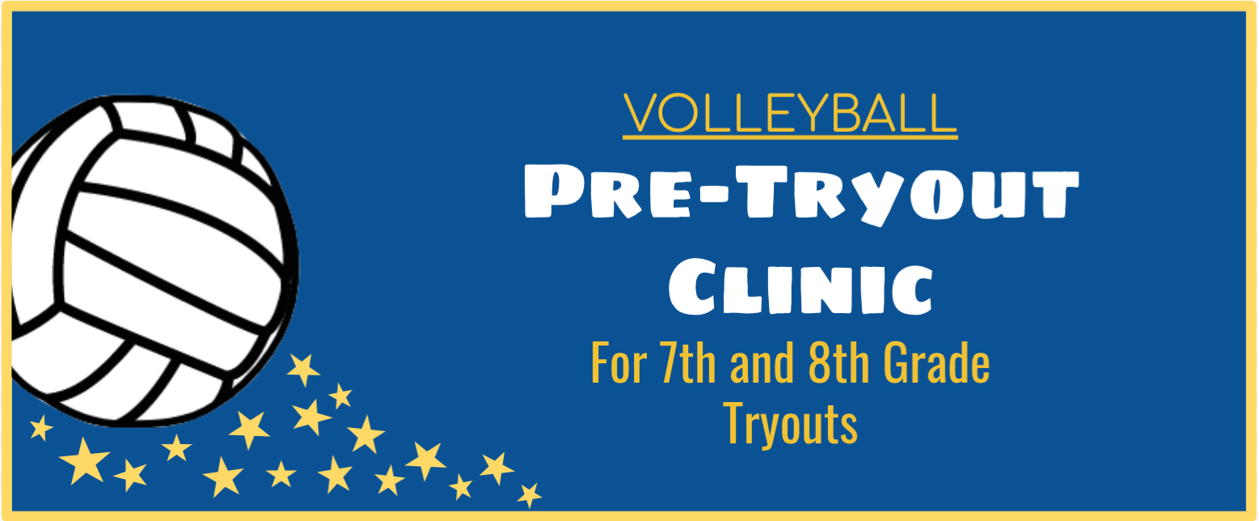

AUGUST 19th & 20th
7th Grade: 8am-11am
8th Grade: Noon-3pm
$75 @ HPHS Gym

- Learn from current High School Players
- Practice Tryout Specific Drills
- Q&A Session about Tryouts
- Focus on skill training, position training, ball control and court movement.
- Leave CONFIDENT and READY for Tryouts!

Questions?
Contact: HPVB 2019 Varsity Captains at
hpscotsvolleyball@gmail.com

ONLINE REGISTRATION IS OPEN!
www.hpvolleyball.org

