Keystone Heights Athletic Clearance
2025-2026
ALL STUDENTS MUST COMPLETE THIS PROCESS TO PARTICIPATE IN ATHLETICS.
IF YOUR STUDENT IS A NON-TRADITIONAL STUDENT SUCH AS HOMESCHOOLED, FLVS, CHARTER, ETC, PLEASE CONTACT COACH DICKINSON FOR THE APPROPRIATE FORMS THAT YOU WILL NEED TO FILL OUT. (904) 336-7841
***PLEASE NOTE: PARTS OF THIS PROCESS MUST BE COMPLETED BY BOTH PARENT/GUARDIAN AND STUDENT ATHLETE***
Keystone Athletics uses AthleticClearance.com. The information is 100% confidential and HIPAA approved.

To become eligible for KHHS Athletics, please complete the following step by step instructions:

Steps to take PRIOR to completing Athletic Clearance -
- Schedule appointment (days/weeks IN ADVANCE, not the day of tryouts) to receive EL02 Sports Physical (Link to EL2: https://fhsaa.com/documents/2023/3/3/EL2_Form.pdf) Please make sure the doctor signed and dated Page 4. That will be uploaded to Athletic Clearance. If your athlete sees a specialist such as cardiologist, orthopedist, etc…page 5 will need to be completed by them and uploaded as well.
- ON OR AFTER MAY 26TH, watch the required 5 videos from NFHSlearn.com: Concussion in Sports; Heat Illness Prevention; Sudden Cardiac Arrest; Bullying, Hazing, and Inappropriate Behaviors for 2025-2026 Athletic ClearanceStudents, and Sportsmanship. See directions below. Download or screenshot the certificates to be uploaded to AthleticClearance.com.

>>>Directions for viewing required videos: Concussion in Sports, Heat Illness Prevention, Sudden Cardiac Arrest, Bullying, Hazing and Inappropriate Behaviors For Students and Sportsmanship..
1. Go to www.nfhslearn.com
2. Create a login and password
3. Click on courses and type in course name (you will have to do this process for each course).
Concussion in Sports https://nfhslearn.com/courses/concussion-in-sports-2
Heat Illness Prevention https://nfhslearn.com/courses/heat-illness-prevention-2
Sudden Cardiac Arrest https://nfhslearn.com/courses/sudden-cardiac-arrest
Bullying, Hazing and Inappropriate Behaviors for Students https://nfhslearn.com/courses/bullying-hazing-and-inappropriate-behaviors
Sportsmanship https://nfhslearn.com/courses/sportsmanship-2
4. Click Order Now - the video is free
5. Select an option and click continue
6. Select Florida as your state
7. Click checkout
8. Click complete purchase - this should be free unless you choose to purchase something else
9. The video course will be under MY AVAILABLE COURSES. Click begin to watch the video. Each video is a different length. Please be sure to allow enough time to watch the entire video.

Once complete, download or screenshot each certificate to be uploaded to the athletic clearance website.

For help viewing the course, please contact the help desk at NFHS. There is a tab on the upper right hand corner of the website.
For questions on the requirement to view the courses, please contact 352-372-9551.

>>>Directions for Athletic Clearance:

New Athletes: (Returning athletes skip to step 5.)
- Go to www.athleticclearance.com and click on FL.
- Please take a moment to watch the tutorial video, then click Register.
- For username, please use a valid email address. Once all fields are complete, click submit. Student Email is your child’s student number ######@myoneclay.net.
- Enter the code shown then click submit
- Once logged in, click ‘Start Clearance Here’
- Enter the following information - Current School Year: 2025-2026, School: Keystone Heights, Sport:(Select any and all sports you plan on trying out for the entire school year.)
- Please fill out all the fields. Student Email is your child’s student number ######@myoneclay.net.
- Upload only PAGE 4 (page 5 also if a specialist is needed) of your EL02 sports physical (pages 1,2, and 3 for your records) and all 4 video certificates. Link to get a copy of EL02. https://fhsaa.com/documents/2023/3/3/EL2_Form.pdf
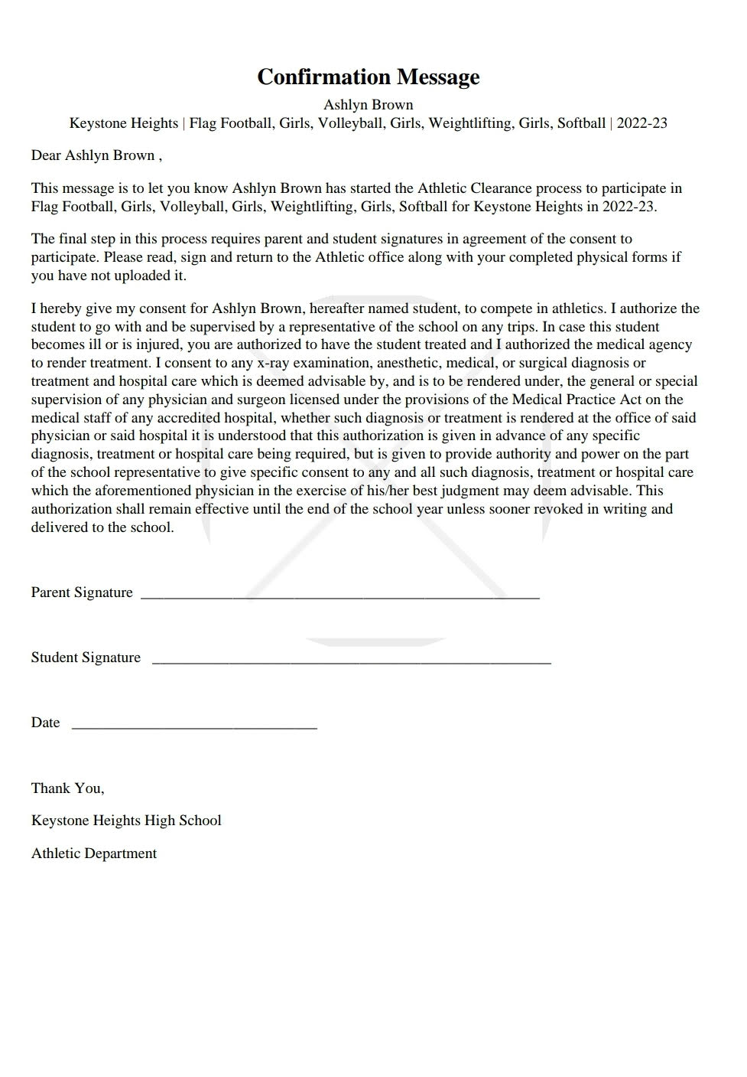
- Please be sure that all signature sections are signed by the required persons, which may include doctor, parent/guardian AND/OR student-athlete.
- Once completed, please PRINT and TURN IN the confirmation page at the end (signed and dated by both parent and athlete) to Coach Dickinson. See pic to the right for reference.
- You cannot participate in any capacity, including tryouts, with any team until you have been cleared by the Athletic Director. Do not wait until the day of conditioning or tryouts to turn in the confirmation page. Same day clearance is not guaranteed. Please plan ahead.

>>>Directions to purchase school insurance if you do not have insurance OR to purchase supplemental insurance:

Go to: schoolinsuranceofflorida.com
Select: Public School
Select: Clay
Select: Keystone Heights Jr-Sr School
Select: School Year
Select: Basic or your choice of insurance coverage
Select: Checkout
Select: Proceed to Checkout
Put your information in to pay.
Please put information for your insurance on Athletic Clearance.

