**Richland Northeast High School is located at 7500 Brookfield Road, Columbia SC 29223**

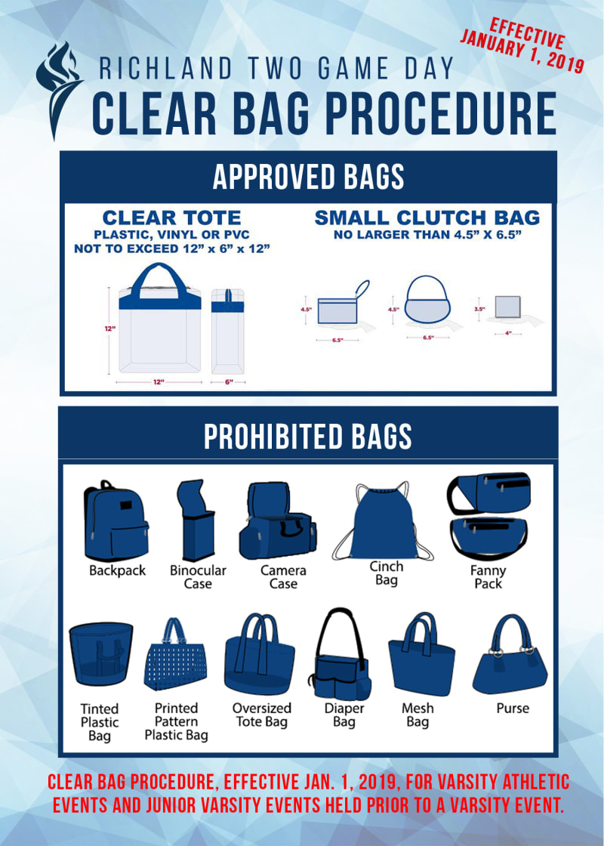

**CLEAR BAG POLICY**

EFFECTIVE January 1, 2019: Richland Two has a clear bag policy at all varsity events and junior varsity events held prior to a varsity event. Fans will not be allowed to bring book bags, large purses, diaper bags, etc. **Please encourage your fans to arrive a little earlier than normal due to these district security measures.**

**TICKET INFORMATION:**

Tickets are available online using the link below. Online tickets are $7.00 (+ processing fee)

[Richland Northeast Athletic Tickets](https://richland2.hometownticketing.com/embed/all?tile_id=2&tile_item=4)

Cash option is available. **Must have exact cash ($8.00)**

Richland Two policy states all students who are entering the game without a parent/guardian, must have a ticket and their school ID to enter.

Gates will close at the end of halftime and no one will be admitted into the game after this time.

**BAND INFORMATION:**

All band members in uniform will be admitted. Please make sure all band members arrive together. Contact our band director, Danyelle Kimp, for any concerns or questions at 803-699-2800 x79863 or [dkimp@richland2.org](mailto:dkimp@richland2.org).

**CHEER INFORMATION:**

All cheer members in uniform will be admitted. Only cheer members, student managers and coaches will be allowed on the track. Contact our cheer coach, Melody Butler, for any concerns or questions at [mbutler@richland2.org](mailto:mbutler@richland2.org). (803) 741-6177

**ATHLETIC TRAINER INFORMATION:**

Our head athletic trainer, LaJoy Paige, will be the point of contact for all athletic training concerns. Her contact information is [lajoy.paige@prismahealth.org](mailto:lajoy.paige@prismahealth.org). (601) 502-5378

**CONCESSIONS**

Concessions will be available. Food trucks are located on the home side only.

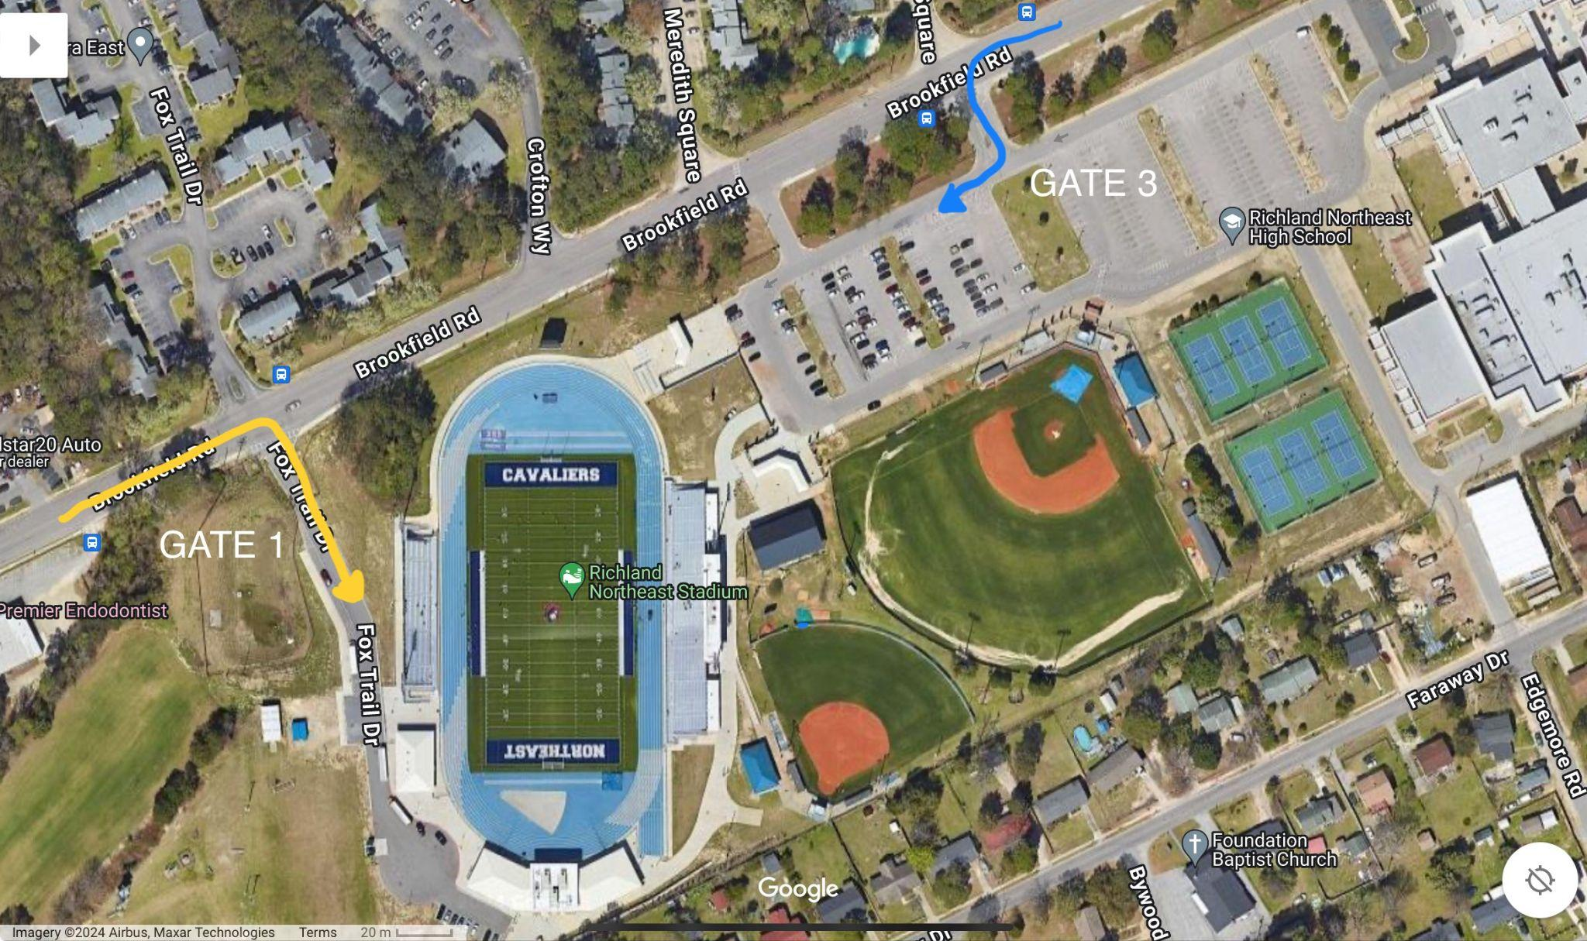

**PARKING AND TRANSPORTATION: Only visiting buses and referees will enter through Gate 1** and spectators will enter through Gate 3 (main entrance).

Contact Information

Mironda Proctor, Athletic Director

[mproctor@richland2.org](mailto:mproctor@richland2.org)

(C) 803-351-8771

Miguel Dozier. Assistant Athletic Director

[mdozier@richland2.org](mailto:mdozier@richland2.org)

Walt Wilson, Head Football Coach/Assistant Athletic Director

[wwilson@richland2.org](mailto:wwilson@richland2.org)

Jacob Lourie, Assistant Athletic Director

[jlourie@richland2.org](mailto:jlourie@richland2.org)