Anderson High School – Trojan Volleyball Updates
**IMPORTANT INFORMATION ATTACHED – PLEASE READ ALL SECTIONS FOR REQUIRED ACTIONS BEFORE THE SEASON**

GENERAL INFORMATION ABOUT THE SEASON:
We have a schedule, it is only a district schedule. We have chosen not to play teams outside our district schedule. We have chosen this to try and minimize the teams possible exposure to COVID.

Things that will be different for us all:

- We will have all the girls practice and play in masks.
- We will be practicing early in the morning for JV/Varsity and after school for the Freshman (attached schedule).
- We will be taking temperatures once they enter the gym.
- We will have hand sanitizer.
- We will sanitize the balls.
- Athletes need to come dressed and ready for practice. (Locker room will not be available at all this year)
- Athletes need to bring their own masks, but if they forget, then we will have disposable masks available for them.
- Athletes need to bring their own water bottles. Water fountains will not be available.
- Try to minimize any extra items coming into the gym.
- Entrance to the gym will only be through the main courtyard doors and then Exit will only be through the exterior doorway by Athletic hallway. (Signs will be posted)

Transportation this season:
- Private Transportation will be needed to transport students to and from games (Attached Form). We will also need a list of students that your daughter will be able to ride with also. If your daughter is riding with someone other than a parent or driving themselves, we will require a note on that day letting us know who will be transporting your child.
- A bus will be available to transport if needed.

Before try-outs start on September 8th, every athlete will need to do the online paperwork, or they cannot try-out.
Here are the steps for the online paperwork:

- Go to austinisd.rankonesport.com in able to go the Parent Portal
- If your daughter played last season, you should have already created an account. If not, you will need to create an account.
- You will need to fill out the Medical History Form- you can download it. If you have a scanner, please scan/email the Medical History to Coach Ngo @ amy.ngo@austinisd.org or Coach Busby @ michael.busby@austinisd.org
- You will also have to complete the Electronic Documents, which are the UIL Forms & Contact Info.

The screen will look like this:

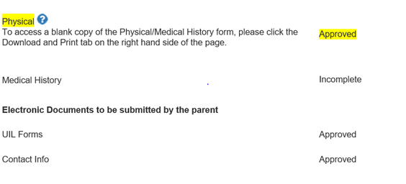

Paper Documents to be Submitted:

If you had a Physical on file, it will show that it is Approved. If you did not have a Physical on file last year, then you will have to obtain a new physical if you haven't had one since April 15, 2019 (not 2020). If you had one if that time frame, then you will need to get a hard copy and have it scanned/emailed to Coach Ngo or Coach Busby.

If you are unable to scan or email these forms, please bring the hard copies and submit them to coaches on Tuesday September 1st. We will be on campus from 9 to 11.

IMPORTANT TRAINER INFORMATION
*ACTIONS REQUIRED PRIOR TO SEASON*
The following paperwork must be completed and on file prior to September 3rd. These documents are as follows:
- 2020-2021 Pre-participation Requirements
- Concussion Baseline From Home

On-campus drive through paperwork drop off dates at athletic entrance will be Tuesday, August 25th 8-10am AND Thursday, August 27th 5-7pm.

NOTE: drive-thru drop-off of paperwork is the preferred method of getting forms to trainers.

TESTS REQUIRED PRIOR TO SEASON:

- COGNIGRAM Concussion Baseline at home testing emails will be sent out Monday, August 24th to parent/guardians of most 9th, 11th, and new-to-sport athletes.

- Concussion Testing needs to be completed before September 8th.
  - See form for complete explanation.

- COVID-19 on campus pre-season testing will take place between August 31-September 3 (dates/times tbd)

Please direct any questions to:

AHS Trainer Team
- Michael Busby, M.Ed., LAT, ATC / michael.busby@austinisd.org
- Amy Ngo, MS, LAT, ATC / amy.ngo@austinisd.org
O: (512) 841-7799
F: (512) 841-6225

