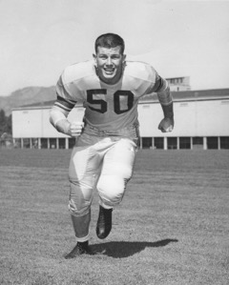
RON PHEISTER
- Graduate of Grant HS - football team member, winning back to back state titles in 1950 & 1951
- Graduate of the University of Oregon - captain of the 1954 football team
- Played in the 1954 East/West Shrine All-Star college football game
- Began teaching and coaching in 1955 at Tigard HS, moving to Grant HS and Benson HS
- 1968 became the assistant Athletic Director for Portland Public Schools becoming Director of Athletic Directors from 1979 - 1988
- Served on numerous committees to the Oregon High School Coaches Association and the OSAA
- Received the National Award of Merit, National High School Coaches Association in 1976
- OADA Athletic Director of the Year in 1988

