Whitehouse High School
This Photo by Unknown Author is licensed under CC BY-SA
Summer Baseball Camp 2022
Students entering 2nd – 8th grades in Fall 2022

Date: June 28 - 30
Location: Whitehouse High School Baseball Field
Time/Session: 8:30am-12pm
Price: $70 per child (2 children in same household $130)
- Each camper will receive a Camp T-Shirt
- Each camper will receive Baseball skills and drills in all aspects of the game from Current Whitehouse Coaches and former players.
Scan Here to Register Online
- Each camper will need a glove, all the baseball equipment they have, and water.
- Daily prizes!
****Please bring money and registration form the first day of the camp!
Additional Questions please contact Head Coach Greg Branch @ branchg@whitehouseisd.org

Make checks payable to Coach Greg Branch
REGISTRATION FORM
Camper Name: _____________________________________Grade Fall 2022:____________________
Address:_____________________________________________________________________________
School Attending in Fall 2022: ____________________________________________________________
Parent’s Name: ________________________________Contact Number:________________
Circle T-Shirt Size Youth: Sm Med LG Adult: Sm Med LG XL
I would like to enter my child in the Whitehouse Baseball Camp. This is to certify that I, parent/guardian, hereby grant permission to Whitehouse baseball Camp to obtain medical care from any licensed physician, hospital or medical clinic for the player named herein at such time as either parent or legal guardian cannot be contacted in person or by telephone. This authorization shall include all camp activities, and we do hereby waive, release, absolve, indemnify, and agree not to hold Greg Branch, Whitehouse ISD, the organizers, supervisors, and participants, for any claim arising out of injury to the player or accidents that may occur during the camp.
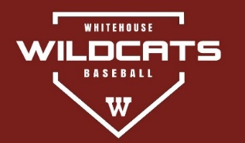
Signed/ Date: ______________________________ ____________

