
2026 Season
TIPPECANOE BOYS SOCCER CAMP
July 13-14th @ Kyle Park 5:30-8:00 p.m.
July 15th @ Tipp Park Stadium 5:30-8:00 p.m.

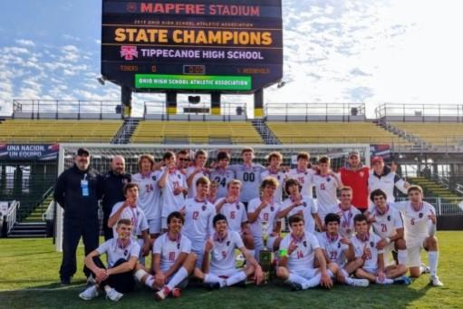


The camp will be offered to all boys who will be entering grades 6-12

The cost will be $60 and includes a camp shirt – Checks should be made out to
Tippecanoe Athletic Department

Mail checks to: Tippecanoe Athletics
Tippecanoe High School
615 E. Kessler-Cowlesville Rd.
Tipp City, OH 45371

The camp will be run by the high school coaching staff and former players

The camp will focus on the following:
- individual ball skills
- improving technique
- combination play and tactical awareness
- attacking and defending in 1 v1, and small sided situations
- finishing on goal
- extensive training in small sided games
- full sided games/mini tournament

All players should bring a ball, shin guards, water, and indoor or running shoes in case of rain.


Please fill out the waiver form and return them with the payment. Please return this as soon as possible. To guarantee shirt size, have form in by June 10 If you have any questions you can contact Coach Slyman at jslyman@tippcity.k12.oh.us.

TIPPECANOE BOYS SOCCER TEAM CAMP

Player’s Name _________________________________________
Grade _____ Fall 2026
Age _______
Size Shirt _______
Parent Name/Guardian and contact
number______________________________________________

In consideration of my entry, I do for myself, my executors, administrators, and assignees, do hereby release and discharge the Tippecanoe Boys Soccer program, Tipp City Exempted Schools and all other sponsors for claims, damages, demands, actions whatsoever in any manner arising or growing out of my participation in any said athletic camp. I attest and verify that I have knowledge of the risks in this camp and I am physically fit and trained to participate.

Parent/Guardian: ________________________________
Signature: ______________________________________
Date: _________________________________

