

For more information contact:

Head Coach Joe Schneider

405.354.0413 school

405.990.8496 cell

joseph.schneider@yukonps.com

www.yukonwrestle.com

Miller Wrestling Camp

June 12th, 13th, & 14th

2018

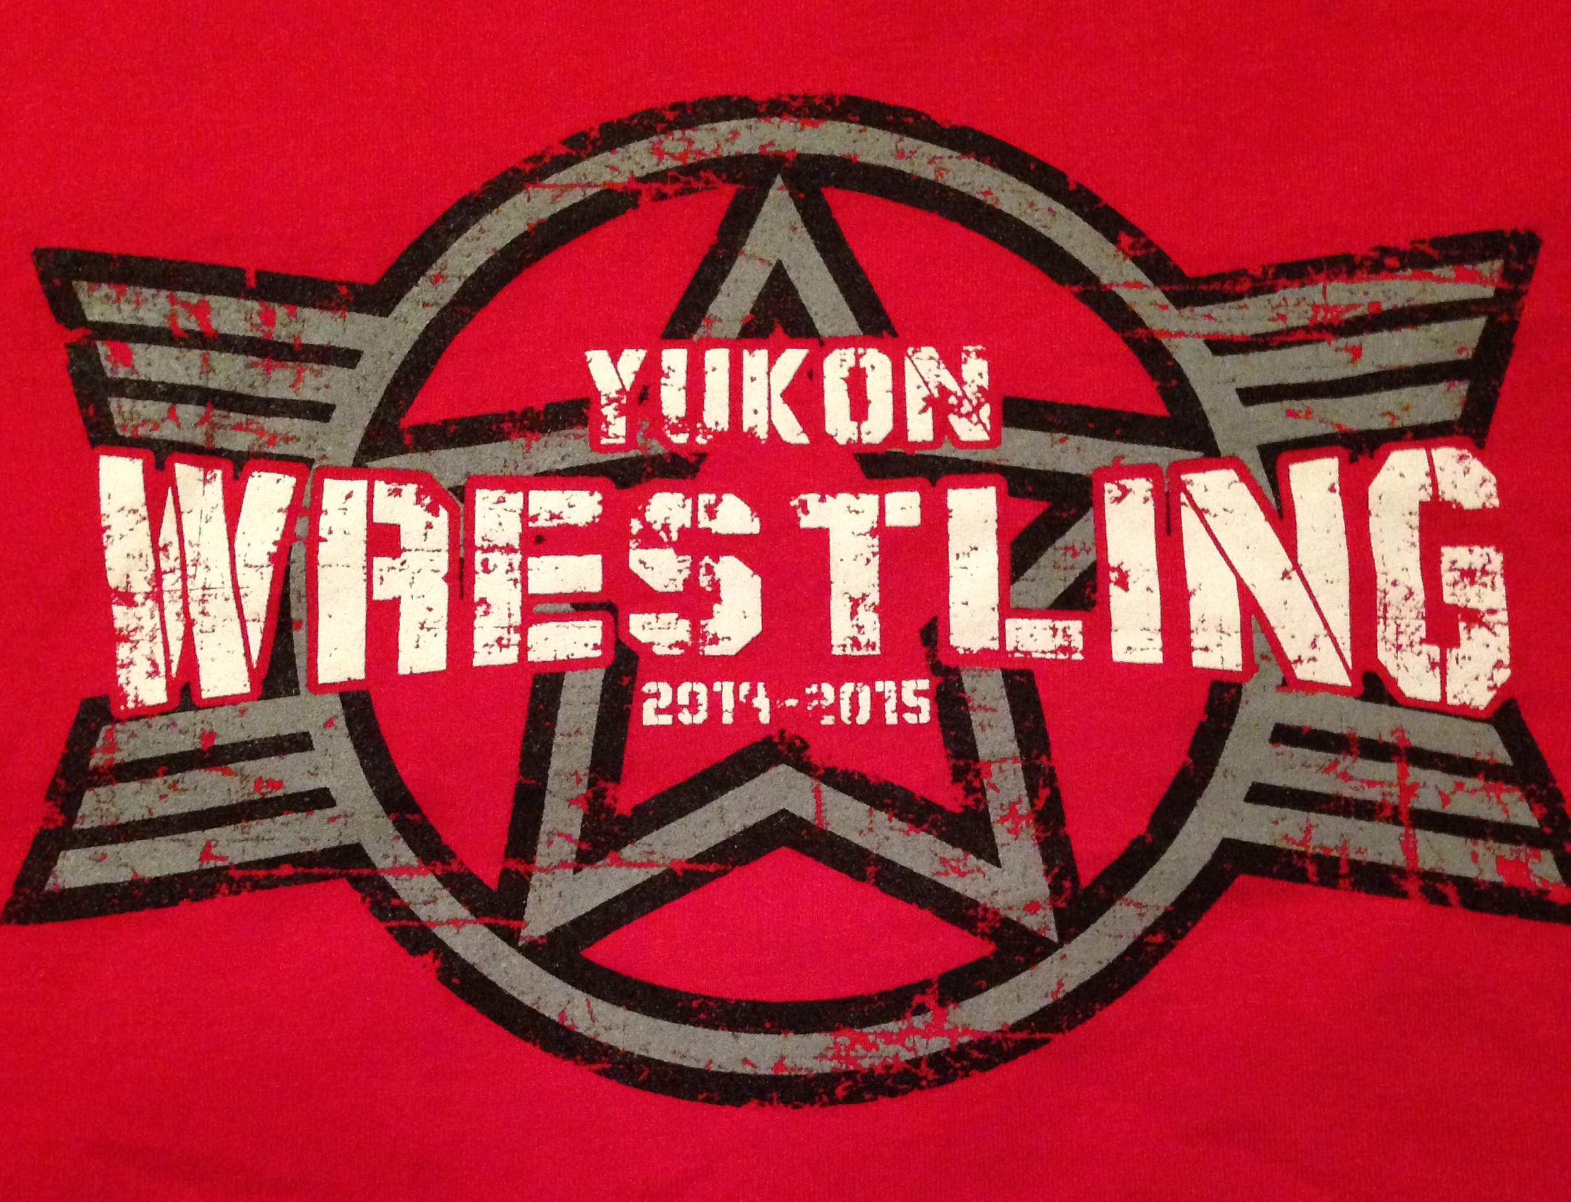

Camper’s Name_____________________

Address___________________________

Age______________________________

T-shirt Size YS YM YL S M L XL

Parent’s Name_____________________

Contact # ________________________

Emergency Contact #_______________

The camp director reserves the right to dismiss anyone for any violations during the camp.

**I understand that all coaching staff at the YHS Wrestling Camp and the YHS School District shall NOT be liable for personal injury or property damage/lost arising from participation in the Miller Wrestling Camp.**

In case of injury or illness, I authorize medical treatment for my Child

__________________________________in my absence.

Parent Signature: ____________________

Date:________________

Yukon Miller Wrestling Camp

Yukon Miller

Wrestling Camp

2018

Complete registration form below and submit with payment.

This spaced be   
used for customer 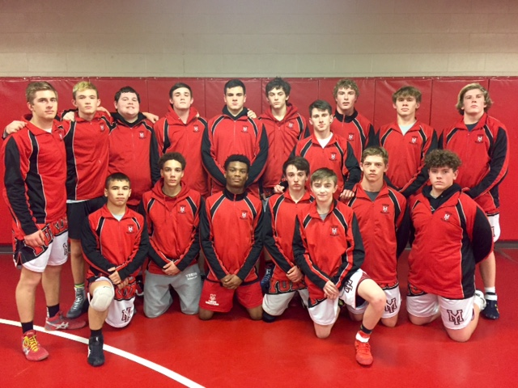  
testimonial quotes,   
or points of interest

The Yukon Miller Wrestling Camp is organized to provide an opportunity for wrestlers of all ages and skill level.

We will provide instruction in both mental and physical aspects of the sport, from players and coaches who have experienced the sport at all levels.

It will be a fun, but competitive atmosphere where the areas of focus will be: Takedowns, Bottom Wrestling (reversals and escapes), and Pinning Combinations that will give the wrestlers that attend the competitive edge over their opponents.

New technique of various moves and a complex workout strategy will be taught.

Games will be played on the last day along with a possible tournament.

Food and Drinks provided for lunch the last day, as well as camp T-shirt.

CLINICIANS INCLUDE:

Joe Schneider

Head High School Wrestling Coach

and

Members of the Yukon High School Wrestling Team

DATE & TIMES:

June 12th, 13h, & 14th

(Tue, Wed, & Thur.)

9:00am –12:00noon

WHO:

All Wrestlers Ages 5 – 14

EQUIPMENT NEEDED:

T-shirt, shorts, and Wrestling shoes

(If you own shoes. If not we have extras.)

LOCATION:

Yukon H.S. Wrestling Room

COST: $60.00

(Price includes camp, lunch on last day and T-shirt)



**REGISTRATION:**

**Complete application form and return it with full fee to:**

* **14673 Clair Ct. West, Yukon, OK 73099.**

**Make checks payable to:**

* **Joe Schneider**

**\*Fee is non-refundable after June 1st.**

**\*All returned checks are subject to an additional $25.00 fee.**

**If you have any questions, please feel free to contact Coach Schneider**

**354-0413 (work) or 990-8496 (cell)**

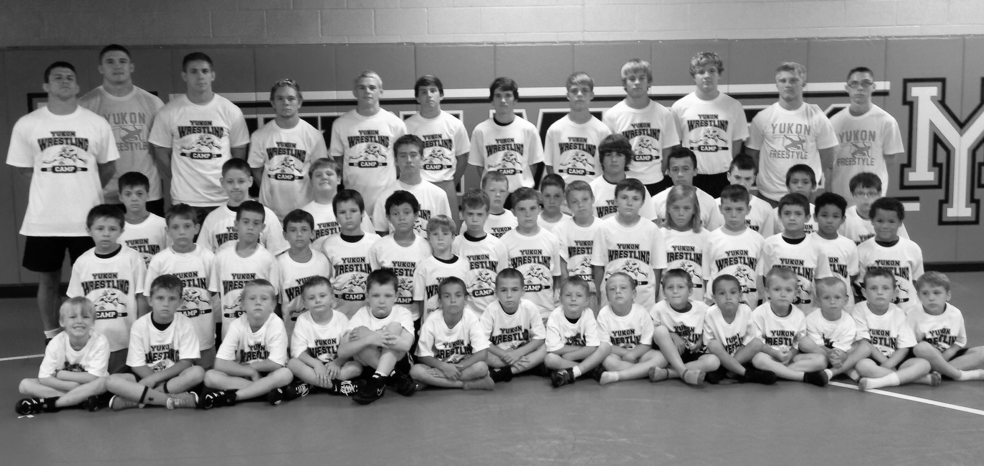

PLACE PHOTO HERE,

OTHERWISE DELETE BOX