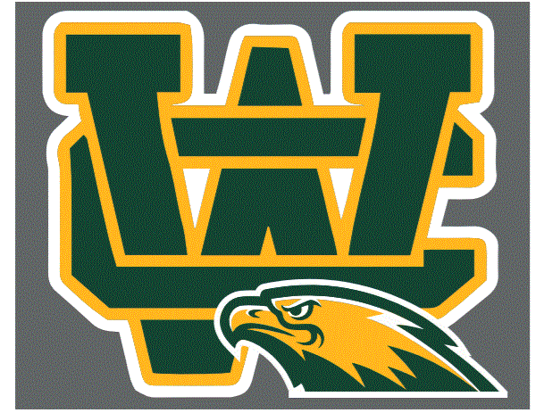
Wilkes Central High School
Athletic Hall of Fame Nomination Criteria and Form

Criteria for Nomination to the Wilkes Central Hall of Fame

- The athlete must have graduated from Wilkes Central at least five years prior.
- The athlete must have demonstrated the highest standard of sportsmanship during his/her years of athletic participation while at Wilkes Central.
- The athlete must have excelled in athletics during his/her years of athletic participation at Wilkes Central, ie. all-league, all-region, all-state recognition.
- Wilkes Central accepts nominations of former coaches, administrators, teams and boosters. Nominees must have served Wilkes Central athletics for a minimum of 5 years.
- Collegiate or adult athletic participation is not a primary part of the criteria for selection.
It is preferred that nominations come from the community rather than the selection committee members. An individual making a nomination is asked to provide an address and phone number in case additional information supporting the nomination is required. No anonymous nominations will be accepted. Nominations will be accepted beginning February 17th, 2017 and close March 20th, 2017. Selections will be announce April 1st, 2017. A Hall of Fame dinner to honor selected members will be held in March 24th, 2017. The selection committee will be comprised of the building principal, athletic director, 2 current WCHS coach, and 2 at-large community members.

All members of the Wilkes Central Eagles community are encouraged to nominate former athletes, coaches, and boosters for a variety of recognitions:
- Hall of Fame – Induction of former athletes/coaches for outstanding achievement in their high school athletic endeavors
- Eagle Award – For outstanding support of Wilkes Central athletics
- Honored Teams – To be recognized at the HOF banquet for team accomplishments

#1 I would like to nominate:

Name Class for

Reason/Accomplishments

#2 I would like to nominate:

Name Class for

Reason/Accomplishments

Please provide your name, address and phone below in case additional information is needed. Mail form to Wilkes Central High School, c/o Jeff Savage, Director of Athletics, 1179 Moravian Falls Rd. Wilkesboro, NC 28697, or email to savagej@wilkes.k12.nc.us

*******************Nominations for class of 2016-2017 will close March 20th 2017***********************
Person Nominating

Name:

Address:

Home Phone:

Work/Mobile Phone:

