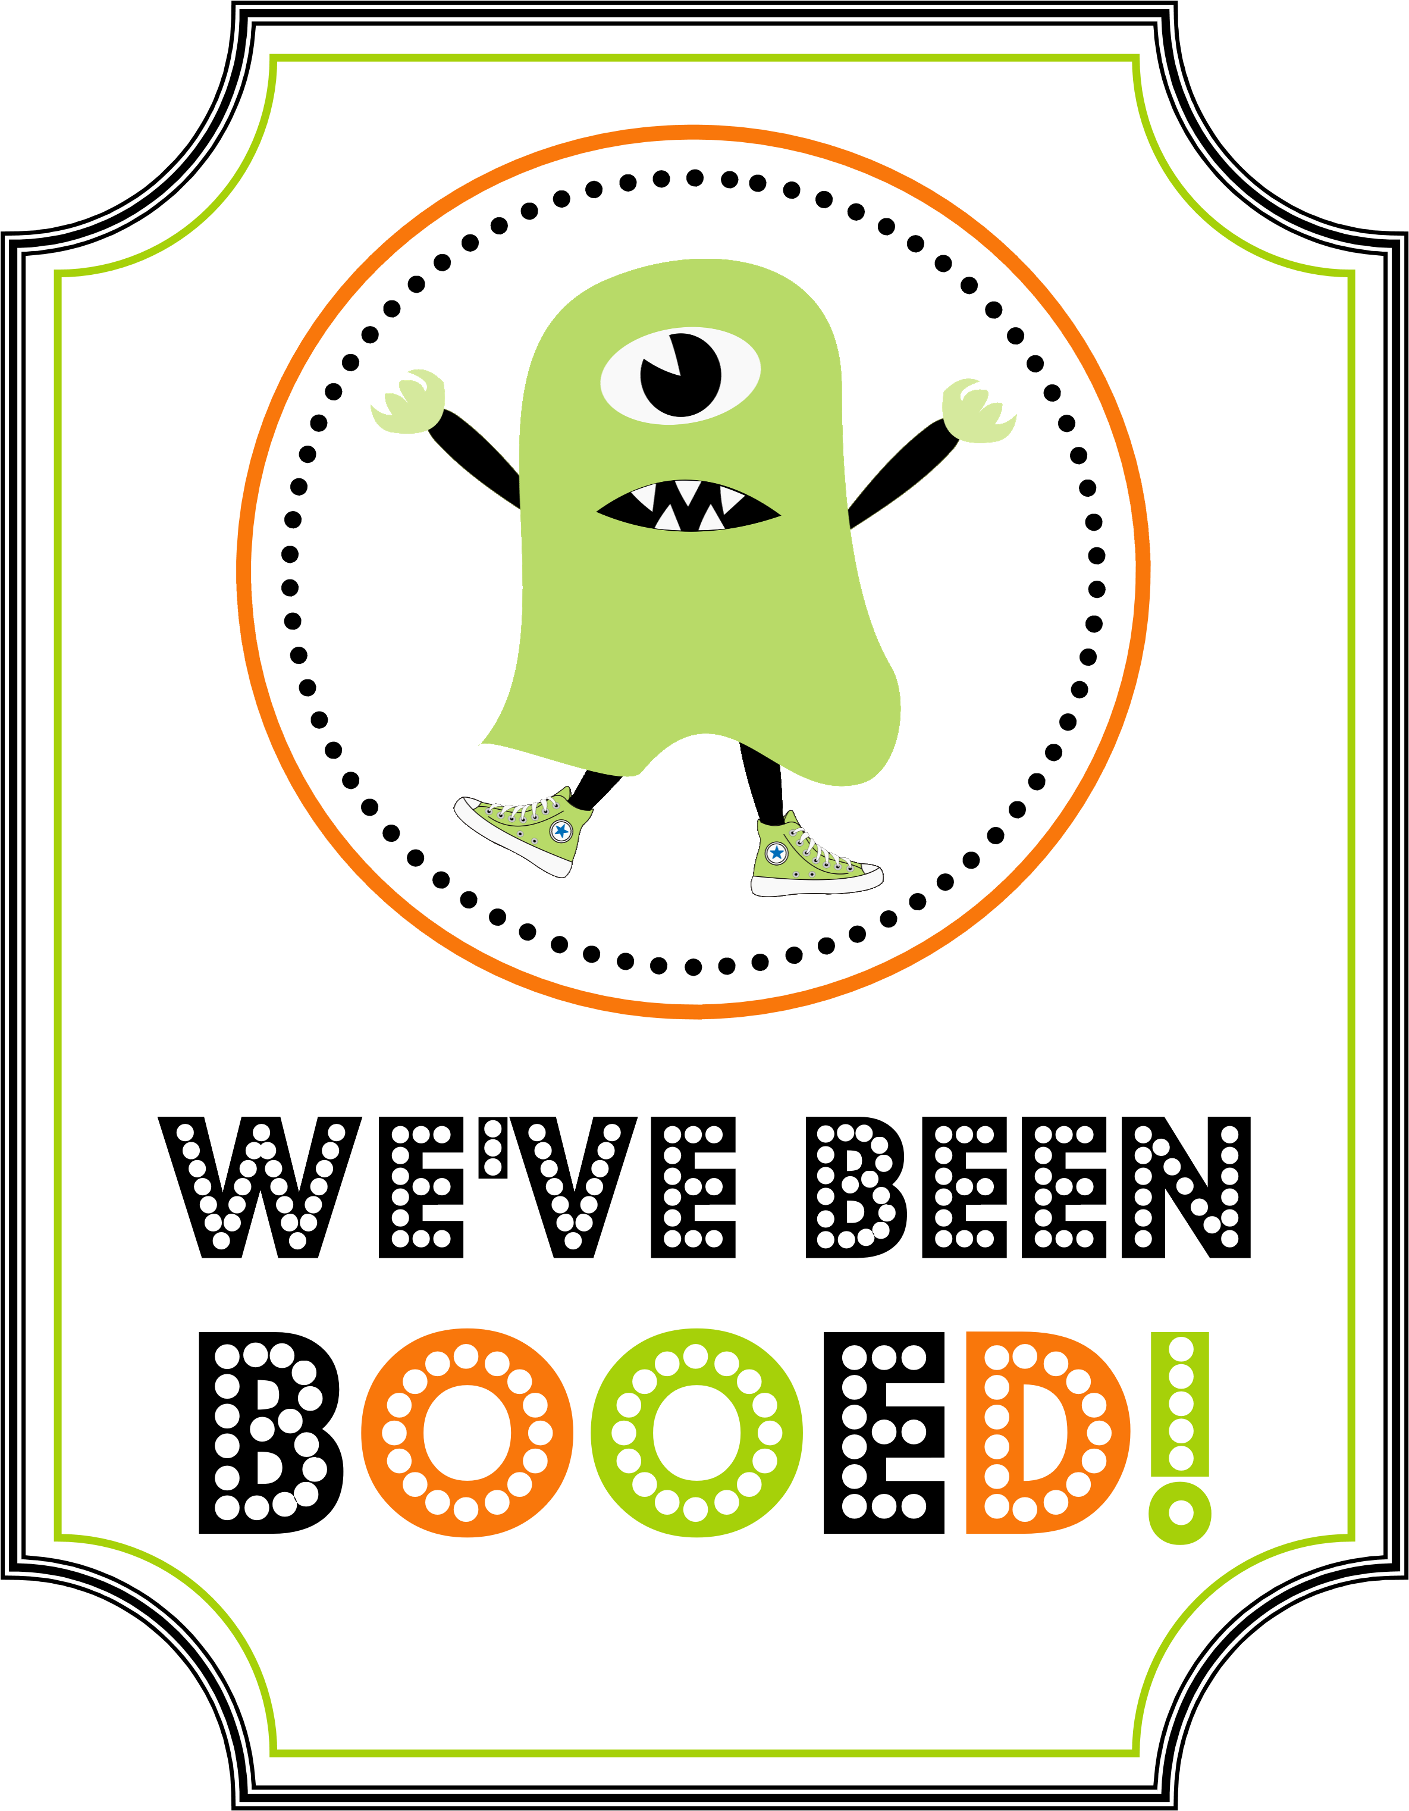

YOU HAVE

BEEN

BOOED!
Please keep it going by following these directions:
- Enjoy your treats!
- Place the “We’ve Been Booed” sign on your front door or in a window!
- Within two days, make two copies of these instructions, two copies of the We’ve Been Booed sign and two yummy treats!
- Secretly deliver to two Lady Rebel teammates who haven’t been Booed yet! If you need addresses, please contact Kelly Lane, kellyplane@sbcglobal.net
HAPPY HALLOWEEN!

